1. 小波分析 检测流程

给定采样的包过程X(n)，采样频率为fs，长度为N，小波分解层数为J，

线下？是不是已经有了 N/fs的时延？

1. 对X(n)进行J层小波分解，得到每层小波系数dj（j∈[1, J]）以及J层近似系数aJ;

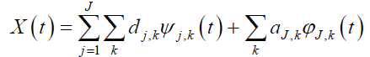

1. 取高层小波分解系数重构攻击子带 Xa(n)

比如 J = 5，取4，5层

1. 取低层小波分解系数以及近似系数重构背景流子带 Xb(n)

取近似，加上 1，2，3层

1. 攻击特征提取

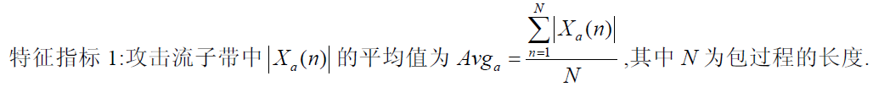

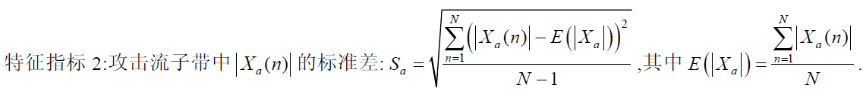



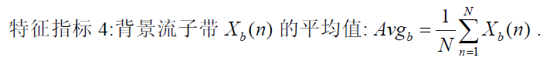

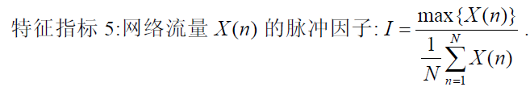

1. 攻击检测

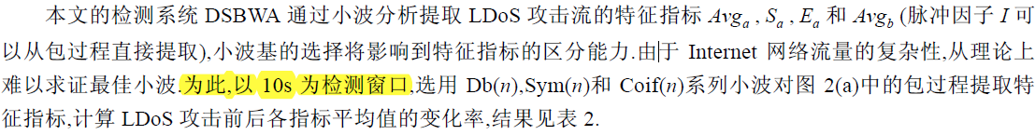

检测窗口TW 10s

1. 攻击时刻鉴定
2. 时延分析

小波分析

|  |  |  |  |  |  |  |  |  |  |  |  |  |  |  |  |  |  |  |  |  |  |  |  |  |  |  |  |  |  |  |  |  |
| --- | --- | --- | --- | --- | --- | --- | --- | --- | --- | --- | --- | --- | --- | --- | --- | --- | --- | --- | --- | --- | --- | --- | --- | --- | --- | --- | --- | --- | --- | --- | --- | --- |
| T |  |  |  |  |  |  |  |  |  | 1 |  |  |  |  |  |  |  |  |  | 2 |  |  |  |  |  |  |  |  |  | 3 |  |  |
| 0 |  |  |  |  |  |  |  |  |  |  |  |  |  |  |  |  |  |  |  |  |  |  |  |  |  |  |  |  |  |  |  |  |
| 1 |  | 1 |  | 1 |  | 1 |  | 1 |  | 1 |  | 1 |  | 1 |  | 1 |  | 1 |  | 1 |  | 1 |  | 1 |  | 1 |  | 1 |  | 1 |  | 1 |
| 2 |  |  |  | 1 |  |  |  | 1 |  |  |  | 1 |  |  |  | 1 |  |  |  | 1 |  |  |  | 1 |  |  |  | 1 |  |  |  | 1 |
| 3 |  |  |  |  |  |  |  | 1 |  |  |  |  |  |  |  | 1 |  |  |  |  |  |  |  | 1 |  |  |  |  |  |  |  | 1 |
| 4 |  |  |  |  |  |  |  |  |  |  |  |  |  |  |  | 1 |  |  |  |  |  |  |  |  |  |  |  |  |  |  |  | 1 |
| 5 |  |  |  |  |  |  |  |  |  |  |  |  |  |  |  |  |  |  |  |  |  |  |  |  |  |  |  |  |  |  |  | 1 |

进行J层分解，2^J个原数据才能出来一个J层的小波系数，因此N>=2^J，

假设N = k*2^J，k∈N+

理想情况：攻击发生在N时刻，立马就能引起指标变化，定位到攻击时刻，

最坏情况：攻击发生在1时刻，必须等N时刻才能计算出指标，再定位攻击时刻，此种情况下时延delay约为N/fs。

原文当中DoS采样时间间隔为100ms，即fs=10Hz，当N=32时，delay=3.2s

检测窗口为10s，即 N 约为100

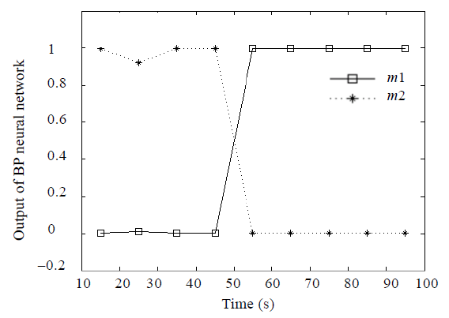

1. matlab仿真

fs =10Hz;NTime = 10;





